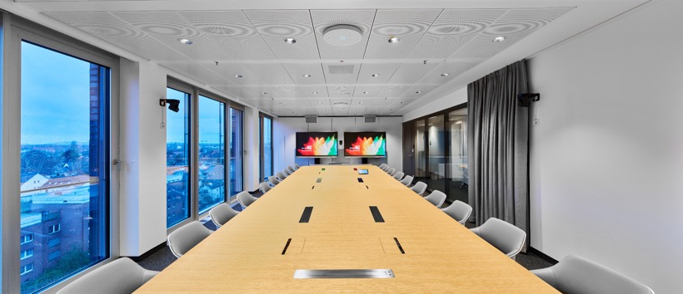©PIK AG 2024

# Hannover’s Chamber of Industry and Commerce becomes one of the first to install Sennheiser’s TeamConnect Ceiling Medium microphones

**TCC M enhances trainings and meetings at IHK Hannover’s new office building**

***Wedemark, July 16, 2025*** **–Sennheiser’s TeamConnect Ceiling Medium (TCC M) microphones were installed in 34 training and meeting rooms of the new office building of Hannover’s Chamber of Industry and Commerce (IHK). Manufactured at the audio specialist’s headquarters in Wedemark near Hannover, 36 TCC Ms were delivered straight from the production plant to facilitate learning and collaboration in IHK Hannover’s new building in the Lower Saxony state capital.**

Hannover’s Chamber of Industry and Commerce (IHK) envisioned their new office building to be a center of exchange and networking. When it came to fitting their 34 meeting and training rooms as well as their plenary hall with ceiling microphones, IHK Hannover and system integrator PIK AG selected Sennheiser’s TCC M microphones to facilitate learning and collaboration in the new office building. Utilizing patented automatic dynamic beamforming technology and Sennheiser’s TruVoicelift function, the TCC M ensures exceptional speech intelligibility by automatically focusing on the speaker's voice, regardless of their location in the room. This innovative feature allows for seamless communication during meetings and training sessions, ensuring that every word is heard clearly.

TCC M is utilized across various rooms at IHK Hannover, primarily for team meetings and hybrid teaching sessions. The first floor features a dedicated teaching area comprising eight rooms, all equipped with the TCC M. Remarkably, the TCC M eliminates the need for presenters or lecturers to use additional microphones, as it effectively captures audio in these hybrid lecture environments. In the CEO meeting room, the integration of Q-SYS with the TCC M facilitates advanced features such as camera tracking, while other rooms utilize simple USB cameras without tracking capabilities. “The decision to implement Sennheiser’s TCC M microphones reflects our commitment to providing innovative media technology to meet the requirements of modern conference and training rooms”, stated Markus Wermers, Project Manager at PIK AG, the main contractor for the project.

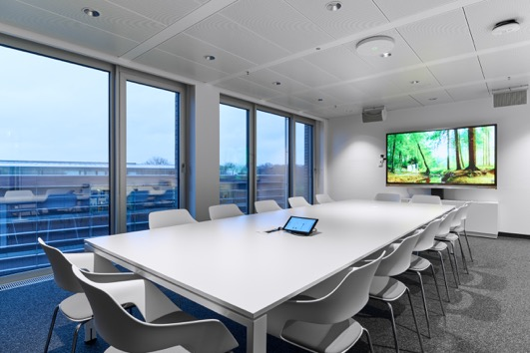

Sennheiser’s TeamConnect Ceiling Medium (TCC M) microphones were installed in 34 training and meeting rooms of the new office building of Hannover’s Chamber of Industry and Commerce (IHK)

© PIK AG 2024

With a coverage area of up to 40 m², the TCC M microphone delivers the advanced audio quality and features found in Sennheiser’s award-winning TeamConnect Ceiling 2 (TCC 2). Their versatile installation options—surface-mounted, suspended, flush-mounted, or using the TCC M Ceiling Tile —allow for flexible room configurations and cleaner setups, creating an optimal environment for collaboration. “Our goal with the TCC M was to empower users in mid-sized meeting environments with superior audio technology,” said Denise Beater, DACH Business Communication Sales Manager Sennheiser. “We are proud to see our TCC M deployed locally in the Hannover region, where they will significantly enhance the overall experience for both in-person and remote meeting participants at IHK Hannover.”

The selection process for the TCC M was driven by the need for a suitable ceiling microphone that could seamlessly integrate with the existing infrastructure at IHK Hannover. During the search for new solutions, it became evident that most ceiling-mounted microphones were too large, including Sennheiser's TCC 2. After exploring options, integrator PIK AG’s Chief Sales Officer, Daniel Gallin, reached out to Sennheiser to inquire about the availability of the newly announced TCC M microphones. At the time, they were not yet on the market; however, the Sennheiser team confirmed their production timeline, ensuring delivery just in time for the project. The family-owned company successfully delivered the first-ever produced TCC M ceiling microphones directly to IHK, starting with serial number 00030. The local connection between IHK Hannover and Sennheiser heightened the excitement, as both organizations share a commitment to quality and innovation in the Hannover region.

Ein Bild, das Wand, Deckenleuchte, Im Haus, Decke enthält.

Sennheiser delivered the first-ever produced TCC M ceiling microphones directly to IHK, starting with serial number 00030

© PIK AG 2024

“We believe that investing in Sennheiser products is an investment in the future of effective communication and collaboration,” Wermers added. “The reaction we’ve received from users has been overwhelmingly positive, and we are excited to see how these microphones will enhance training sessions and hybrid meetings at IHK Hannover.”

**About the Sennheiser Brand – 80 Years of Building the Future of Audio**

We live and breathe audio. We are driven by the passion to create audio solutions that make a difference. This passion has taken us from the world’s greatest stages to the quietest listening rooms **–** and made Sennheiser the name behind audio that doesn’t just sound good: It feels true. In 2025, the Sennheiser brand celebrates its 80th anniversary. Since 1945, we stand for building the future of audio and bringing remarkable sound experiences to our customers. While professional audio solutions such as microphones, meeting solutions, streaming technologies and monitoring systems are part of the business of Sennheiser electronic SE & Co. KG, the business with consumer devices such as headphones, soundbars and speech-enhanced hearables is operated by Sonova Holding AG under the license of Sennheiser.

[www.sennheiser.com](http://www.sennheiser.com)

[www.sennheiser-hearing.com](http://www.sennheiser-hearing.com)

**Global Press Contact**

Jeff Horan

+1 860-598-7539

jeffrey.horan@sennheiser.com

**Press Contact DACH**

Jacqueline Gusmag

+49 (0) 5130 600 – 1540

[jacqueline.gusmag@sennheiser.com](mailto:maik.robbe@sennheiser.com)